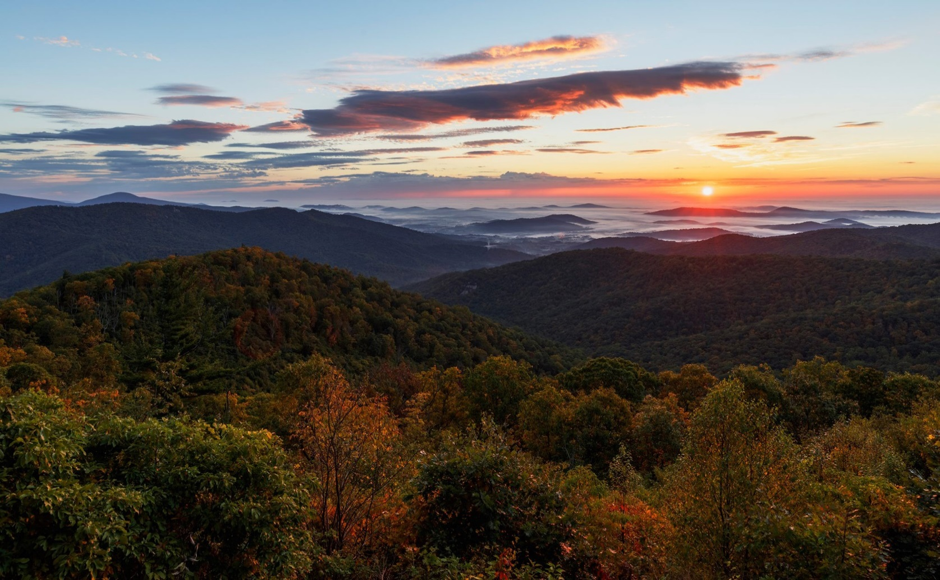
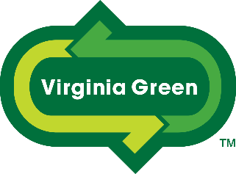

Protecting Virginia’s Environment
Supporting Sustainable Tourism
Educate Engage Results

The Virginia Green program strives to educate the tourism industry about sustainable practices and innovative products that can significantly reduce the environmental impacts of their operations. Furthermore, Virginia Green strives to engage our partners and consumers in a meaningful dialogue that is mutually beneficial. Together, we strive to promote the Virginia Green partners and achieve environmental results.

Virginia Green Certification

Over the past 10 years, 1800+ tourism businesses have voluntarily certified their environmental commitments and practices and been recognized as certified Virginia Green Partners. The program is administered by the non-profit Virginia Green Travel Alliance (VGTA) and works in partnership with the Virginia Tourism Corporation, the Virginia Department of Environmental Quality, and the Virginia Restaurant, Lodging & Travel Association.

2 Levels of Virginia Green Certification
The VGTA currently provides for 2 levels of certification and recognition.
- Virginia Green Commitment Level only requires that the tourism business certify that they have made categorical commitments to implement sustainable practices and are working to make progress. Many businesses choose to start at the Entry Level and then being working towards Full Certification.

- Fully-Certified Virginia Green Partners have fully implemented a required number of sustainable practices in various categories such as recycling & waste reduction, water & energy conservation, and green event management. Certified Partners undergo a full application review that may require the submittal of photographs and other documentation.

Virginia Green Travel Partner: Commitment Level
This is the actual application to become a Virginia Green Travel Partner -- Commitment Level. Commitment level is an easy way for a business to become engaged with the program and its educational resources, while receiving some preliminary recognition for its pledge to be a more sustainable business. The intent is to get started and then become a fully Certified Virginia Green Travel Partner in the near future.

How To Apply & How Does the Program Work?
- Fill out the checkbox application on the following page & submit to VirginiaGreen@Virginia.org.
- If you have provided all of the necessary information, the application will be approved; and you will be notified by email. An Application Processing Fee will be due at that time (see details next page).
- You will then receive a certificate, window stickers, and a membership placard to display. You will also be emailed official program logos for use on your website, marketing materials, etc.
- Virginia Green will announce you as a Virginia Green Partner via social media and in our newsletter.
- The Virginia Green logo will be placed next to your listing on the Virginia Tourism website (www.Virginia.org), and your local Virginia Green Travel Chapter website (if applicable).
- You will receive announcements about regional educational offerings including our annual Virginia Green Travel Conference & Awards.
- You will be eligible to apply for our awards which annually recognize 30+ Virginia Green partners.
- Every 2 years, all Virginia Green Partners are required to renew their commitments or move up to the Certified Virginia Green Partner level.
Virginia Green Application Processing Fees
Commitment Level Fully-Certified
- Restaurants, B&Bs, Wineries, Breweries, & “Smaller” Attractions $50 $75
- “Larger” Attractions $95 $175
- Hotels $125 $195*
- Conference Centers NA** $175*
- Convention Centers NA** $250
- Conferences, Festivals & Events NA** $75
- Supporting Organizations, Visitor Centers, etc $50 $75
- Suppliers of Green Products & Services NA $125
*Conference Centers & Hotels can be certified together for $300 total.
**NA: there is no “commitment level” for Conference & Convention Centers or Festivals & Events.
Fees can be waived for events and other partners that sponsor a fundraising event benefiting the VGTA.
Supporting organizations & local-government facilities/events can be waived or addressed on a case-by-case basis.
Ownership groups and other organizations may be eligible for group rates.
Recertification is required every 2 years.

Checklist Application

Virginia Green Entry Level Partner Requirements
To qualify, you must be able to check all of the boxes below:
☒Recycling. Our business is actively recycling materials that are readily recyclable in our community; and we are providing our customers with opportunities to recycle. Recycling is an absolute requirement for the Virginia Green Commitment Level. (If you are unable to recycle for some reason, please explain below*)
☒Polystyrene Disposables. Our business has eliminated the use of polystyrene (commonly referred to as “styrofoam”) take-out containers and cups.
☒Energy Conservation & Efficiency. Our business is actively working to reduce the use of electricity and other energy sources through conservation and use of energy efficient appliances, lighting, equipment, and practices.
☒Water Conservation & Efficiency. Our business is actively working to reduce water use through general conservation and replacement/use of water-efficient fixtures, appliances, and practices.
☒Green Meetings & Events. Our business pledges to provide for recycling, reuse of meeting materials, electronic handouts, and to reduce wastes to the greatest extent possible when hosting meetings and events.
☒Consumer Engagement. Our business pledges to share its environmental efforts with its customers and promote that it is a Virginia Green Partner on its website, in its business, and in promotional materials.
*Please Feel Free to Share Additional Information About Your Efforts:

Applicant Contact Information
Name of Business _The Founders Inn and Spa_
Type of Business _Hotel/Inn_
Address _5641 Indian River Road_ City / State _Virginia Beach, VA_
Contact Name(s) _Delaney Davis_
- Phone _(757)366-5779_
- Email _delaney.davis@foundersinn.com_
- Website _www.foundersinn.com_

Please scan and send application to VirginiaGreen@Virginia.org
Questions? Call 804.986.9119

